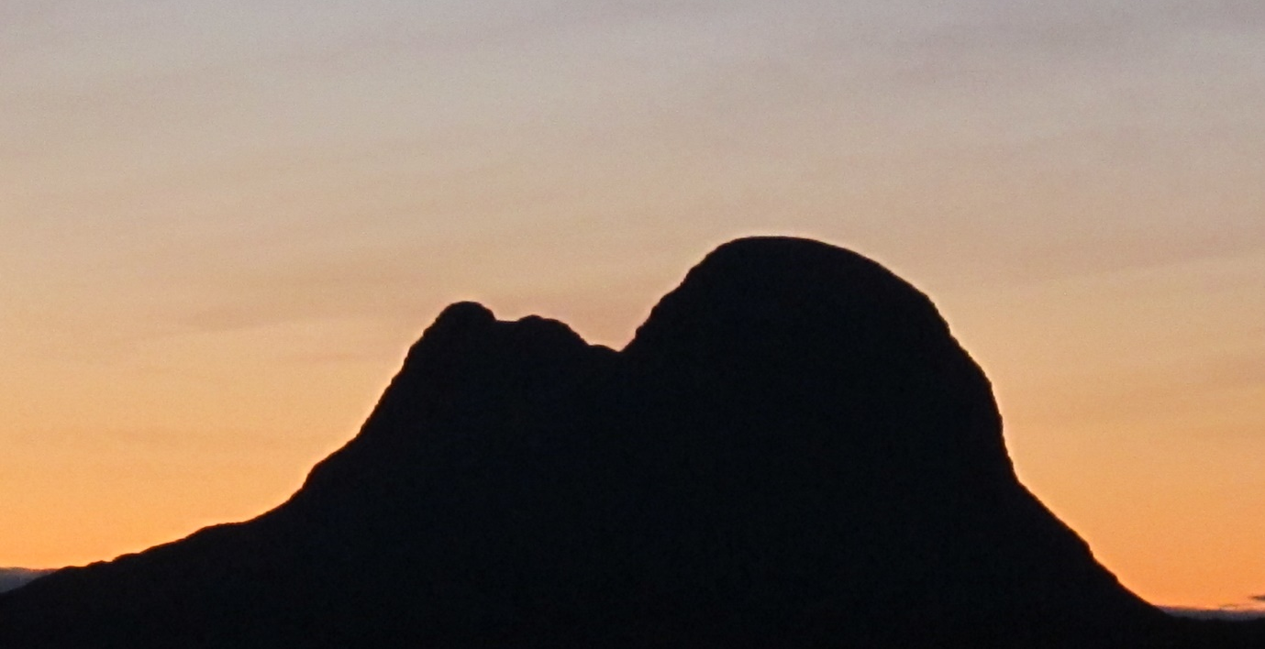

Invitation for application for a Suilven Artist Residency
The Coigach and Assynt Living Landscape Partnership CALLP, funded by the National Lottery Heritage Fund, in association with the Assynt Foundation, is issuing this open invitation for expressions of interest to apply for an Art Residency to focus on Suilven, a mountain of distinctive shape and character, and one that is ranked among the most iconic in Scotland. Suilven dominates much of Assynt Foundation’s 44,000 acres of community owned land.
Major work has been funded by CALLP to improve and conserve the footpath providing access to the summit of Suilven. The recent and previous human interventions raise many questions and issues of significance for artistic exploration, and creative expression across a broad spectrum of perspectives and disciplines. But there is more to Suilven than the footpath and human interventions, and we are open to proposals that address whatever artists wish to express by whatever form of creative endeavour.
Click here for some images of Suilven
More can be found and information provided on both the Coigach & Assynt Living Landscape Partnership, and the Assynt Foundation by following the links below.
Chris Puddephatt: https://coigach-assynt.org/2018/09/weve-done-suilven/
Also for CALL: https://coigach-assynt.org/
Assynt Foundation: http://www.assynt-foundation.co.uk/
North West Geo Park: https://www.nwhgeopark.com/
Outputs
The Assynt Foundation (AF) is managing this project as a partner with CALLP. The key outputs required by the funders are;
- Creation of a piece of work of artistic value and relevance concerning Suilven.
- Two open workshops to explore with participants the process and reasoning behind the art work to be produced.
- Two School Visits of children from local schools. The organising of these events will be undertaken by staff employed by CALL. This limits the role of the resident to engaging with the children to talk about their project and this aids the interpretation of its significance.
The outline programme for linked residency activity in 2019 is likely to be;
Initial visit by chosen artist during May within main period of residency in June. The visit in May will ideally coincide with a special event to celebrate the completion of the Suilven footpath restoration. This will provide a good opportunity to meet a wide range of people with close connection with Suilven. The workshops with local schools are likely to be held in June. If it proves impossible to hold these in June they will be re-scheduled for late August/September. Arrangements for these workshops will be undertaken in collaboration with the CALLP education and events staff. The other workshops for local community and visitors will be arranged by agreement for either June or later in the summer.

The expectation is that the successful applicant/s will spend time in Assynt during the months of June – October, with completion of the required work by the end of September. Also that successful applicant/s will undertake a research and development period ultimately leading up to concept design and creation. We are looking for this to involve engagement with others involved with the geology, conservation and wild life on Assynt and surrounding land. (Geo Park, Rangers, Assynt Field Club, Stalkers, Woodland restoration)
The residency project will have a small support group drawn from local people able to assist the artist with making contacts and other matters requiring local knowledge.
The fee to cover all artist(s) travel, accommodation, materials and completed art work and their time is a total of £5,000. If there is an issue over the exact numbers of days an artist can commit to this residency, this will be resolved by reference to prevailing rates recommended by Scottish Artists Union in relation to experience.
There are no limits being placed on the form of the final art work or the chosen artistic medium. Reference has been made to artists in the plural and again there is no prior expectation that this be a solo residency. The limitation here is that of funding and the practical realities of costs of travel and accommodation to a remote part of the North West of Scotland.
It is hoped the artist will willingly provide a regular blog to be posted on local websites to aid communication and contact with the wider community and further afield.
The Assynt Foundation has an arts studio (see images on Vimeo link) that will be available for use by the resident(s) for own work and the conduct of the workshops. This has been currently reserved for the art residency through the month on May and June (with scope to extend to cover additional time periods). Consideration is being given to how this space can also be utilised as a genuine place of residence for the chosen artist. The artist in residence in 2018 had her own camper van, and the chosen artist may choose to make own arrangements. The cost of accommodation must be met from within the overall fee paid to the artist.
Requirements and process.
To apply for this opportunity you must:
- Provide a CV, with detail of past projects relevant to this application.
- Details of your website and/or ten images of recent art work, or digital examples of written, performance, audio visual or work that indicates nature and content of your creative activity.
- Statement setting out initial ideas of how you will approach this residency; the activities you will undertake; why you are interested in engaging with this subject; an indication of your availability, and the time you can give to this project. This should be no more than 1,000 words.
The deadline for receipt is: 12 noon Monday 8th April. Applications must emailed to brochartsres@gmail.com and all will be acknowledged by email. Given potential for mail entering spam folders, please contact Nigel Goldie (brochartsres@gmail.com ) if you do not have an acknowledgement within 24 hours.
Shortlisting will take place in week beginning April 15 and a decision made by the end of that week

