Experienced designer needed to develop and produce interpretation board(s) for the honesty shop at Glencanisp
Background
The Assynt Foundation (AF) and John Muir Trust (JMT) are working together through the Coigach & Assynt Living Landscape Partnership (CALLP) Scheme to repair and upgrade the path to the community owned hill - Suilven. This is a two year project (2017-2018) and we are keen to produce interpretation of the path work to ‘tweak’ people’s interest in Suilven and the work being undertaken (including the associated community, culture, geology, wildlife etc.)
The job
Produce and install interpretation panels to tell the story of the path work and provide information about the Assynt Foundation and the environment, so that visitors can better appreciate the area. The panels should also direct visitors to other sources of information about the path project (AF, JMT and CALLP) and encourage donations to the ongoing work of the Assynt Foundation.
Audience
Visitors to Glencanisp, particularly walkers heading up Suilven or walking other paths and trails in the vicinity. This will include family groups, experienced hill walkers, recreational tourists, cyclists, other visitors to Glencanisp and guests at the Lodge etc. of all ages. As Gaelic is a key part of the local culture the interpretation boards will need to feature text in both English and Gaelic.
Brief
Involve the local community to identify the key themes and messages for the interpretation panels, produce copy, source images, design and get approval for the interpretation boards, supply final art work for print, liaise with the printer and organise delivery and installation. This will involve working closely with the project partners and potentially local schools and other groups such as the NW Highlands Geopark.
The interpretation boards will hang in the honesty shop. The available wall space is approximately 3.5m wide x 1.2m high and is protected from the weather and elements. The shop currently features basic information about the Assynt Foundation and the path work, as well as providing facilities for making tea/coffee and buying snacks.
The interpretation will follow the Assynt Foundation brand guidelines (fonts/colours) and feature logos for Assynt Foundation, CALLP and John Muir Trust, as well as the funders: Heritage Lottery Fund, EOCA, SMT and SNH. The interpretation boards will need to be sturdy and durable but, where possible, be made from environmentally friendly materials.
Budget and timescale
There is a budget of up to £2,000 available for the development, design, printing and installation of the interpretation panels. This budget is to cover all of the development costs including the designer’s time, travel, accommodation and subsistence as well as their own equipment.
Work on the path will be ongoing from May to the end of August 2018 and it is desirable that the interpretation panels are developed during this period. We aim to have the interpretation panels completed and installed by the end of 2018.

Interested? Here’s how to apply…
We welcome applications from experienced interpretation designers. Designers must be available to meet project partners and spend time in Assynt in order to work with relevant parties. Interested parties should meet the following criteria:

Essential
- Experience of developing content and messaging for interpretation panels
- Experience of designing the style, layout and artwork of interpretation panels
- Experience of working with local community and interest groups
- Own design facilities and equipment
- Own transport
- Good communication and project management skills
- Availability during Summer 2018

Desirable
- Familiarity with or knowledge of the Assynt Foundation, John Muir Trust, CALLP, Suilven and Assynt
- Experience of working with schools
- Background or understanding of geology and natural and cultural history of Assynt

Interested parties should complete the attached application form and return it to: Chris Goodman, c/o Coigach & Assynt Living Landscape, 1 Old Coach House, Lochinver, IV27 4LE or electronically to chris.goodman@johnmuirtrust.org by Friday 13th July 2018.
Applications will be assessed by John Muir Trust, Assynt Foundation and CALLP staff and applicants will be informed of the outcome of the application at the earliest opportunity.

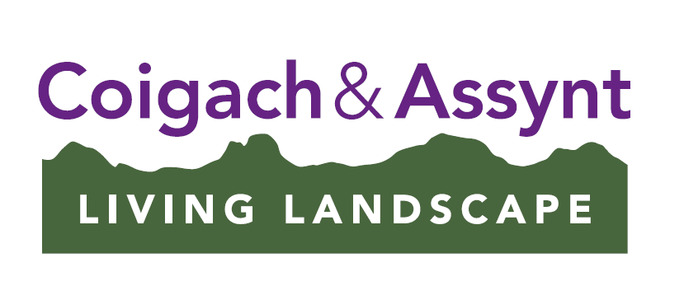
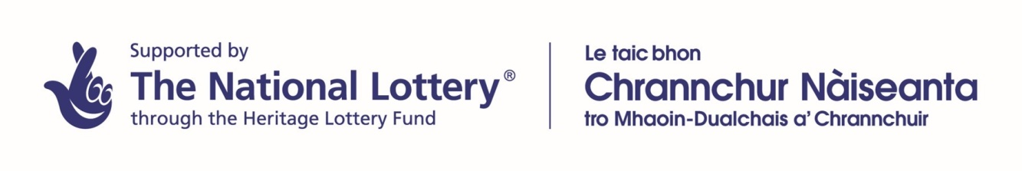
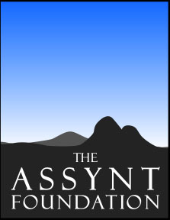
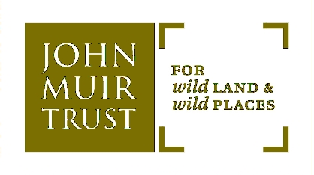
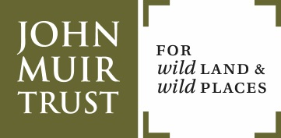
Application Form for the Suilven Path Repair Project Interpretation Boards
Name: Home Telephone:
Date of Birth: Mobile:
Address: Email:

Relevant Experience:
Please provide details of relevant interpretation projects you have worked on in the last 5 years along with relevant online links.
Project | Organisation | Date | Description and further information

In the box below please explain why you are interested in this project
In the box below please describe in further detail one of the interpretation projects you have worked on highlighting how you engaged with partners, local groups and/or schools and how you developed the messaging and style. Where relevant please provide an online link to the project or provide a copy of the relevant material in digital or paper format along with this application as an example of the finished design.

In the box below please outline what you would be able to undertake and produce within the stated project budget as well as a quote for delivering this project giving details or estimates where possible on materials used, the number and size of panels, printing and translation costs, etc.

References:
Please provide two relevant referees from within the last 5 years for whom you have worked for or with.

Name:
Organisation:
Contact Address:

Name:
Organisation:
Contact Address:

Please return application forms to:
Chris Goodman, Path Officer, John Muir Trust, 94 Achmelvich, Lochinver, IV27 4JB

